**Big mart sale prediction**

Wireframe Documentation

We will have only one homepage. In the page user will ask for details.

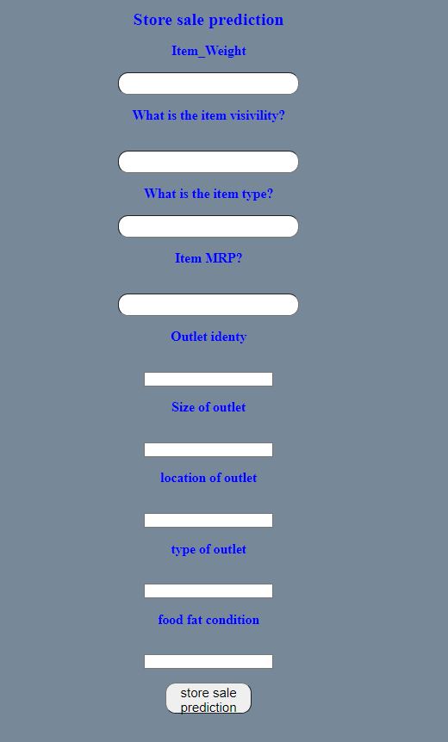

Based on User’s input, our BMSP System wil give predict sale value.